Michael Ragsdale – C++ Assignment 1

# Assignment 1, Program 1 of 2: Volume Calculator

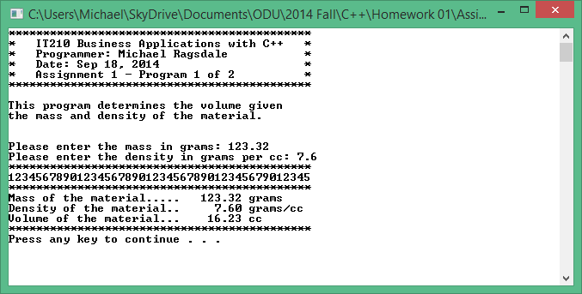

# Assignment 1, Program 2 of 2: Credit Card Calculations

